CHAPTER FOUR
IMPLEMENTATION OF SOLUTIONS TO ELIMINATE OVERLOAD PROBLEM IN POWER SYSTEMS

4.1 Overview
Voltage stability analysis examines the ability of a power system to maintain acceptable voltage levels in response to both abrupt and gradual disturbances. This chapter mentions different kinds of software programs that can be used in order to simulate the study cases specially overload case and solution cases. Also, it mentions values and specifications for every case. Finally, the efficiency and benefits of these solutions are discussed.

4.2 Software Programs
Electrical power systems are combinations of electrical circuits and electromechanical devices like motors and generators. Engineers working in this discipline are constantly improving the performance of the systems.
In real life there are many software programs to simulate power systems circuits such as Power System Simulator (PSS™E), NEPLAN Electricity, ETAP Enterprise Solution for Electrical Power Systems, Dig SILENT Power Factory, Power World Simulator, and Matlab Power Simulating. But unfortunately the costs of these program are too expensive may be reached to 25000 Euro.

4.2.1 Matlab Power Simulating
Requirements for drastically increased efficiency have forced power system designers to use power electronic devices and sophisticated control system concepts that tax traditional analysis tools and techniques. Further complicating the analyst’s role is the fact that the system is often so nonlinear that the only way to understand it is through simulation.
Land-based power generation from hydroelectric, steam, or other devices is not the only use of power systems. A common attribute of these systems is their use of power electronics and control systems to achieve their performance objectives.
Matlab simulator power systems was designed to provide a modern design tool that allows scientists and engineers to rapidly and easily build models that simulate power systems. Also it uses the Simulink environment, allowing the operator to build a model using simple click and drag procedures.
Not only drawing the circuit topology rapidly, but the analysis of the circuit can include its interactions with mechanical, thermal, control, and other disciplines. This is possible because all the electrical parts of the simulation interact with the extensive Simulink modeling library. Since Simulink uses MATLAB as its computational engine, designers can also use MATLAB toolboxes and Simulink blocksets. SimPowerSystems and SimMechanics share a special Physical Modeling block and connection line interface.
Users can rapidly put SimPowerSystems to work. The libraries contain models of typical power equipment such as transformers, lines, machines, and power electronics. The capabilities of SimPowerSystems for modeling a typical electrical grid are illustrated in demonstration files.

4.3 Proposed Study Cases
Proposed study case is a power system circuit in the medium voltage level, 66KV, with15 buses. The system consists of two main steam turbine generators, two delta-delta step up transformers, thirteen transmission lines with maximum current capacity of 270A, and nine loads with their delta-wye step down transformers.
This full load circuit will be modified by assuming that there are new loads connected to the old loads in order to be overloaded as a result from limitation of generation and transmission line or limitation or as a result from transformers.
After that some solutions to eliminate overload will be applied to the overload circuits which are summarized in adding parallel generator to the main generator, adding distribution generator near the heavy loaded, adding parallel transmission line, adding bundle transmission line, putting parallel distribution transformer to the old transformer.
The solutions will be applied depending on the type of the overload that the system is suffered. For any power system it may face either one of these limitations or all of them together.
The proposed towers are designed to hold the weight of the existing lines and the changes in the solutions.
These circuits will be explained in details with its values and specifications in the next sections. The results and analysis will be shown after these specifications.
Matlab software programs are used to simulate these study cases. Appendix B shows the circuits as it’s in Matlab simulator.

4.3.1 Full load Circuit
Full load case study is consist of two main steam turbine generators, two step up transformers, thirteen of transmission lines, and nine loads with its step down transformers are shown in figure 4.1. The main goal for simulating this circuit is to use the real current and voltage values of the loads to compare it with current and voltage values of the overload circuits.
In this circuit, two 60 MW, 7.5 kV generators are applied in two different areas. Every generator is connected to step up transformer by the mean of Δ-Y connection. This changes the voltage from 7.5kV to 70kV.
There are 13 transmission lines with different distance. In the beginning, it is assumed that all lines have approximate current capacity equal 1000A. After the real current values are obtained, the construction of transmission lines will be changed to its original values. Matlab program calculates R, L & C values per km length after entering line’s thickness ratio, diameter and resistance value.
At the end of transmission lines, there are nine step-down transformers. The values of each power transformer vary according to the assumed load power values. Noticing that in the low voltage side, only big loads and high consumption rates such as industrial areas are considered.
The two generators are connected to power system stabilizer because of the disturbances occurring in a power system induce electromechanical oscillations of the electrical generators. These oscillations, also called power swings, must be effectively damped to maintain the system's stability.
Three capacitor banks are connected to the system to support the shortage of reactive power which is caused from the losses of equipments or transmission lines.
Next tables give more details about full load circuit and the values of every component separately; table 4.1 shows the rating of main two steam turbine generators, table 4.2 represent the transformers specifications especially its type , power, and rating, table 4.3 shows transmission lines distances , finally table 4.4 give the active , reactive, and apparent power values of the loads.

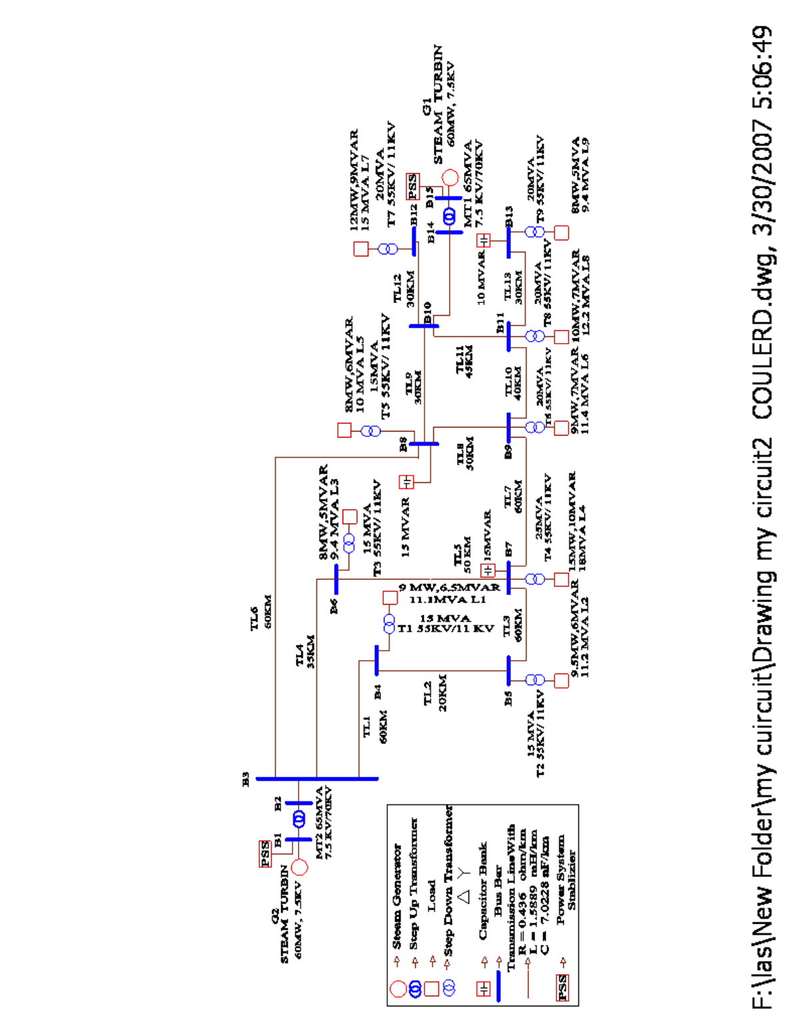
Figure 4.1 Proposed Case Study (full load circuit)
Table 4.1: Generator Values
Generator Number | Power Generated | Generator Rating
1 (G1) | 60MVA | 7500V
2 (G2) | 60MVA | 7500V

Table 4.2: Power Transformer Values and Voltage Ratings
Transformer Number | Transformer Type | Power Transformer | Transformer Rating
1 (MT1) | Step Up /Main | 65MVA | 7.5KV_70KV
2 (MT2) | Step Up/Main | 65MVA | 7.5KV_70KV
3 (T1) | Step Down/Distribution | 15MVA | 55KV_11KV
4 (T2) | Step Down/Distribution | 25MVA | 55KV_11KV
5 (T3) | Step Down/Distribution | 15MVA | 55KV_11KV
6 (T4) | Step Down/Distribution | 20MVA | 55KV_11KV
7 (T5) | Step Down/Distribution | 15MVA | 55KV_11KV
8 (T6) | Step Down/Distribution | 20MVA | 55KV_11KV
9 (T7) | Step Down/Distribution | 20MVA | 55KV_11KV
10 (T8) | Step Down/Distribution | 20MVA | 55KV_11KV
11 (T9) | Step Down/Distribution | 20MVA | 55KV_11KV

Table 4.3: Transmission Line Distances
Transmission line Number | Distance
1 (TL1) | 60km
2 (TL2) | 20km
3 (TL3) | 60 km
4 (TL4) | 35 km
5 (TL5) | 50km
6 (TL6) | 60km
7 (TL7) | 60 km
8 (TL8) | 50 km
9 (TL9) | 30 km
10 (TL10) | 40 km
11 (TL11) | 45 km
12 (TL12) | 30 km
13 (TL13) | 30 km

Table 4.4: Load Characteristic in Full Load Circuit
Loads Number | Active power (MW) | Reactive power (MVAR) | Apparent power (MVA)
1 (L1) | 9 | 6.5 | 11.1
2 (L2) | 9.5 | 6 | 11.2
3 (L3) | 8 | 5 | 9.4
4 (L4) | 15 | 10 | 18
5 (L5) | 8 | 6 | 10
6 (L6) | 9 | 7 | 11.4
7 (L7) | 12 | 9 | 15
8 (L8) | 10 | 7 | 12.2
9 (L9) | 8 | 5 | 9.4

4.3.2 Overload Circuits
In order to obtain an overload circuit, all loads are increased between (20% to 40%) table 4.5 shows the changing of active , reactive, and apparent power load values. If the loads’ voltages are less than 0.95 from nominal voltage, it will be considered as overloaded. In this thesis the main causes of overload are categorized in the following:
- Overload Caused by Limitations of Generations and Transmission Lines
- Overload Caused by Limitations of Transformers

Table 4.5: Load Characteristic in Overload Circuit
Loads Number | Active power (MW) | Reactive power (MVAR) | Apparent power (MVA)
1 (L1) | 11 | 8.5 | 13.9
2 (L2) | 12.5 | 9 | 15.4
3 (L3) | 10 | 7.5 | 12.5
4 (L4) | 20 | 14 | 24.4
5 (L5) | 9 | 6.6 | 11.2
6 (L6) | 12 | 8 | 14.4
7 (L7) | 15 | 12 | 19.2
8 (L8) | 15 | 10 | 18.3
9 (L9) | 12 | 7 | 13.9

4.3.2.1 Overload Caused by Limitations of Generations and Transmission Lines
The two main generators with 60MW are fully loaded, approximately 1pu, in full load circuit. However, in overload case after increasing the loads the two generators will be heavy loaded, limitation of active and reactive power, and become overloaded. In figure 4.2 shows the proposed overload circuit.
The transmission lines in the full load circuit are not fully loaded. It does not have the maximum transfer capability of the current. It’s designed to carry maximum 270A.Therefor the distribution transformers are designed in order to not be overloaded.
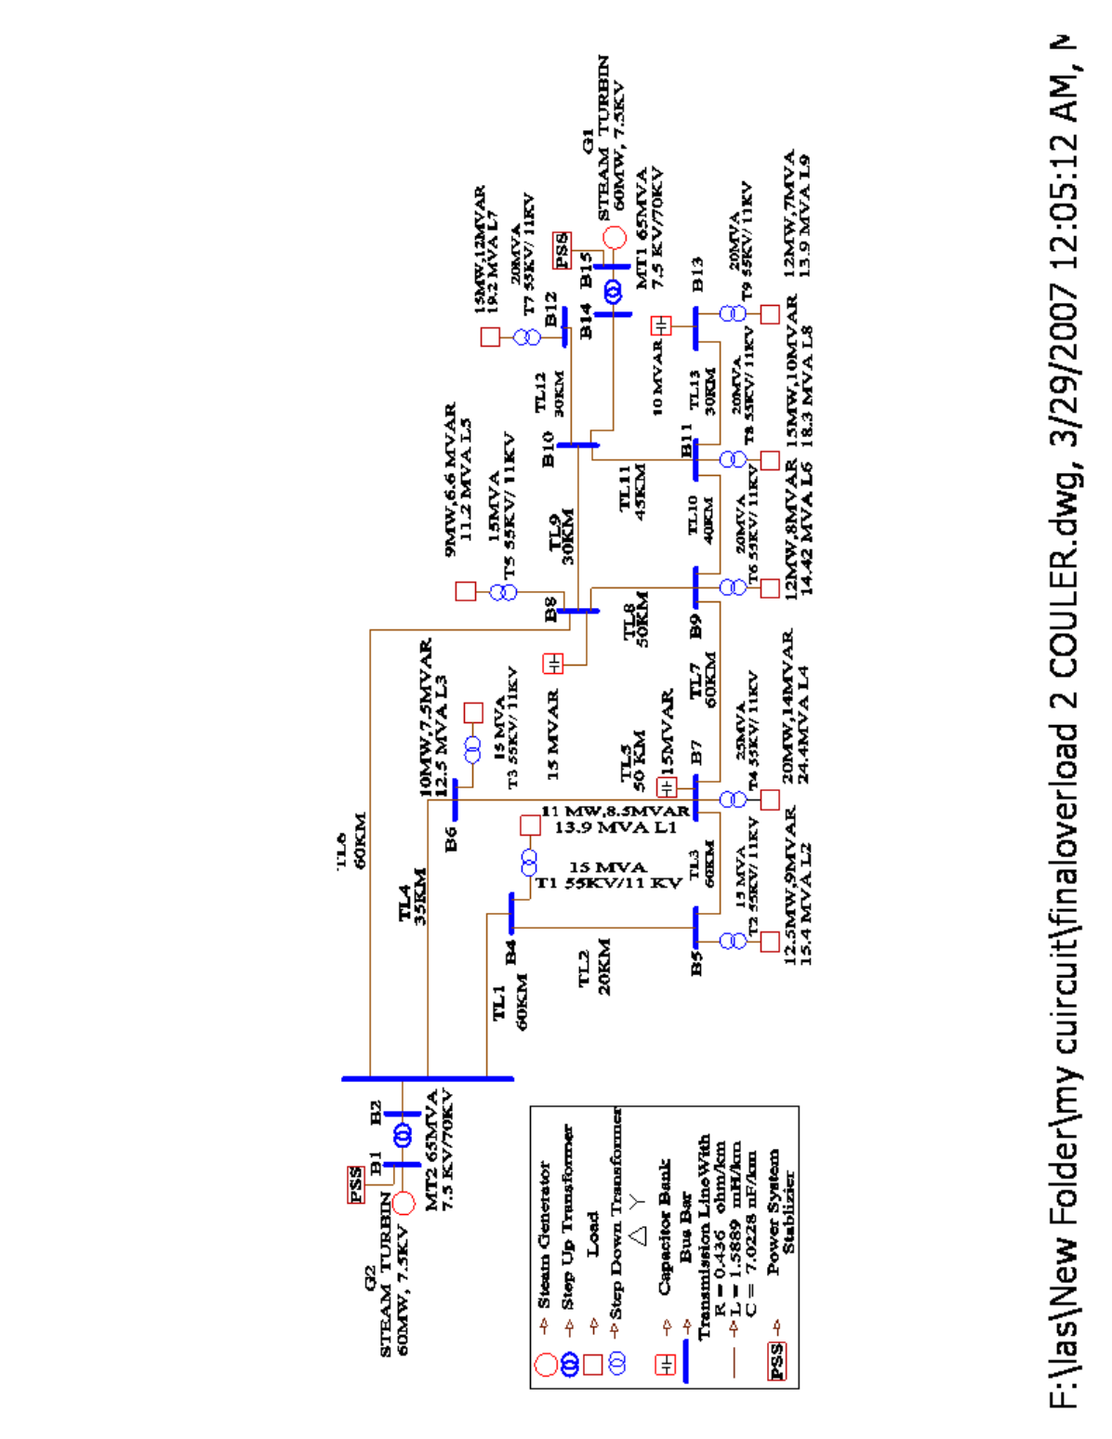
Figure 4.2 Proposed Case Study (overload circuit)
4.3.2.2 Overload Caused by Limitations of Transformers
In the full load circuit all transformers are designed to carry the loads. The values of power transformers are above the values of the power loads. When selecting a distribution transformer, a transformer with a KVA rating 10 to 20% higher than initially required should be considered in anticipation of larger load requirements that it’s loaded approximately 120%.
In order to show the limitations of transformers without considering generation and transmission line limitation, some changes in the power loads of full load and overload circuits which are explained above. In the new proposed circuits only three loads will be increased to have an overload circuit with transformer limitation which is the loads (1, 4, and 5) as shown in table 4.6. The changes of the power load will be more than the power transformer tolerance which is above 120% shown in figure 4.4.

Table 4.6: Comparing Between Full Load and Overload Circuits in the Loads (1, 4, 5)
Loads Number | Full load Circuit |  | Overload Circuit
Loads Number | Transformer  MVA | Load  MVA | Transformer  MVA | Load  MVA
1 (L1) | 10 | 8.2 | 10 | 11.2
4 (L4) | 15 | 14 | 15 | 20.1
5 (L5) | 15 | 15 | 15 | 30

A. Full Load Circuit

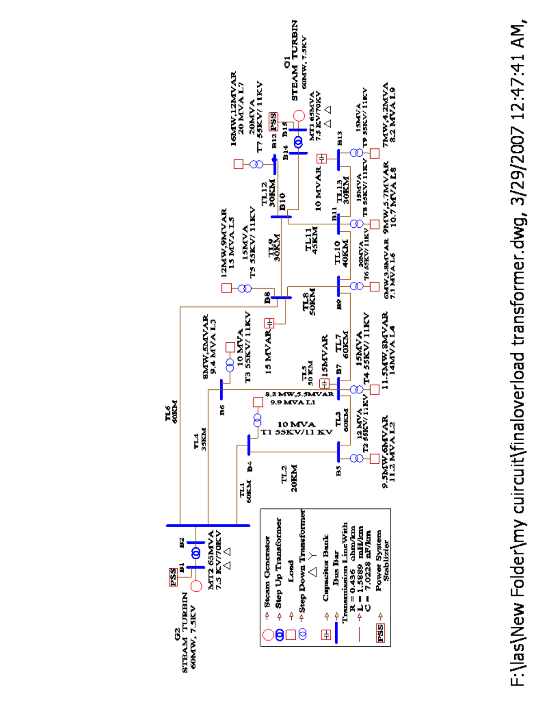
Figure 4.3 Proposed Case Study (Full Load Circuit Considering Transformer Limitation)
B. Overload Circuit
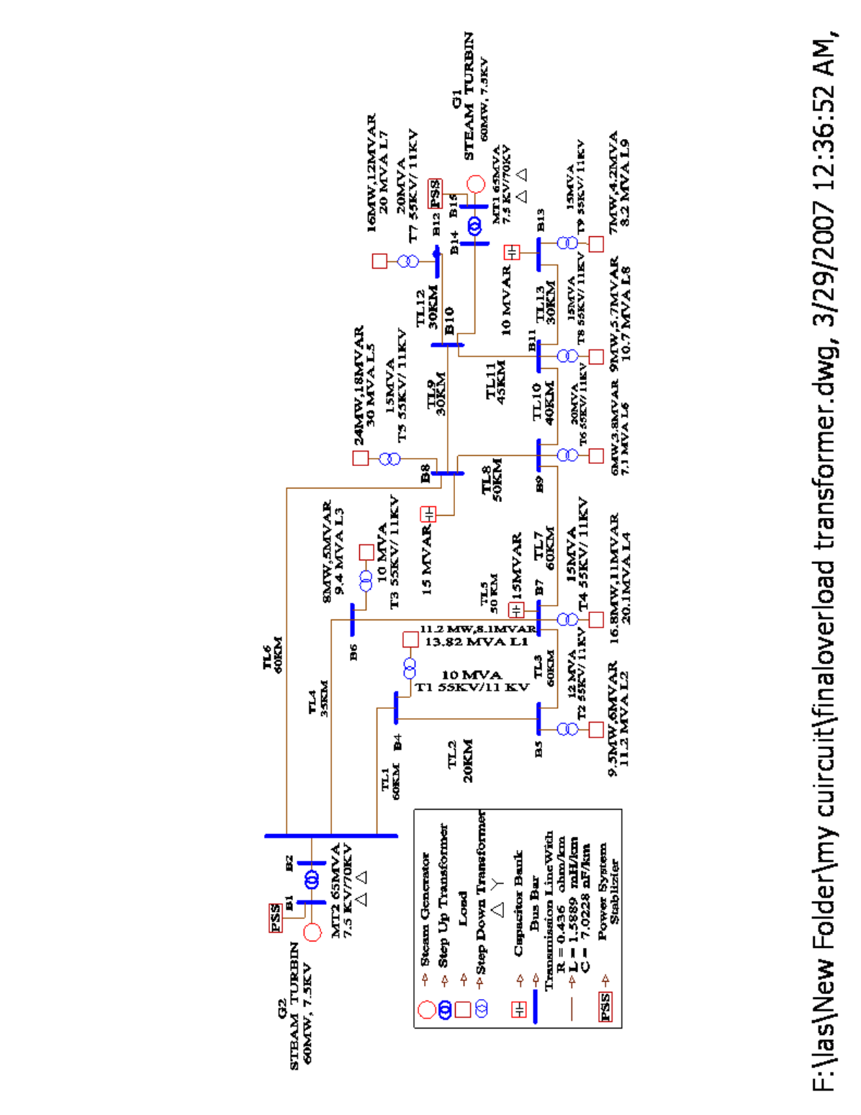
Figure 4.4 Proposed Case Study (Overload Circuit Considering Transformer Limitation)
4.4 Overload Eliminations (Solutions)
To avoid outage of major power system facilities and loss of different power system components, especially the overload problem. Several overload alleviation solutions have been proposed in the literature. In [43] generation rescheduling and load shedding with the help of a local optimization concept are considered to alleviate line overloads, also for [44] an efficient, simple and direct technique to select the best line (the most effective line) to be switched out also a partial rescheduling of spinning reserve generation is then carried out in order to alleviate or remove an overload in a monitored line, using the sensitivity parameters of the N-matrix. [45] A fast computation technique in real power line overload alleviation by generation scheduling and or load shedding has been proposed by using injections at the terminating bus bars of the overloaded line.
And in [46] a simple and efficient method for eliminating branch overloads in power systems, Generation rescheduling (GR) and load shedding (LS) are used as controls. Control actions are defined through the use of non linear programming.
These solutions are considered as short term overload solution or in other word its corrective control actions and remedial actions that the operators made to elevate overload problem.
The thesis will introduce real life application solutions for long term voltage instability that depending on the type of the overload that the system is suffering. The main types are limitation of generation, limitation of transmission line and limitation of transformer, for any power system it may face either one of these limitations or all of them together. These solutions will be categorized into three different ways which are:
- Increasing the capability of transfer power of the transmission lines by:
- Converting from single conductor to bundle conductors
- Adding new transmission lines parallel to the most loaded transmission line.
- Increasing the generation capacity by:
- Adding reserve generators in the power plant
- Adding distribution generators to the systems
- Increasing the capacity of the distribution transformers by adding reserve parallel distribution transformers.

4.4.1 Convert from Single Conductor to Bundle Conductors (Solution 1)
In this circuit, the first solution will be applied which is converting the most heavy loaded transmission line to bundle conductor (two wires) shown in figure 4.5. Table 4.7 shows the differences between the R, L & C / km values of single and bundle conductors which are calculated by Matlab program for the 270A transmission line using all aluminum conductor shows in Appendix A table B1.

Table 4.7: RLC Values of the Transmission Lines in per km
Transmission Line | R(ohm/km) | L(mH/km) | C(nF/km)
Single Conductor | 0.436 | 1.5889 | 7.022
Bundle Conductor | 0.21805 | 1.2027 | 9.2969

Table 4.8 shows the type of the each transmission line if it is single or bundle conductor.

Table 4.8: Transmission Lines Structure
Transmission line | Type of Transmission line
1 (TL1) | Bundle
2 (TL2) | Bundle
3 (TL3) | Bundle
4 (TL4) | Bundle
5 (TL5) | Single
6 (TL6) | Single
7 (TL7) | Single
8 (TL8) | Single
9 (TL9) | Single
10 (TL10) | Single
11 (TL11) | Bundle
12 (TL12) | Bundle
13 (TL13) | Bundle

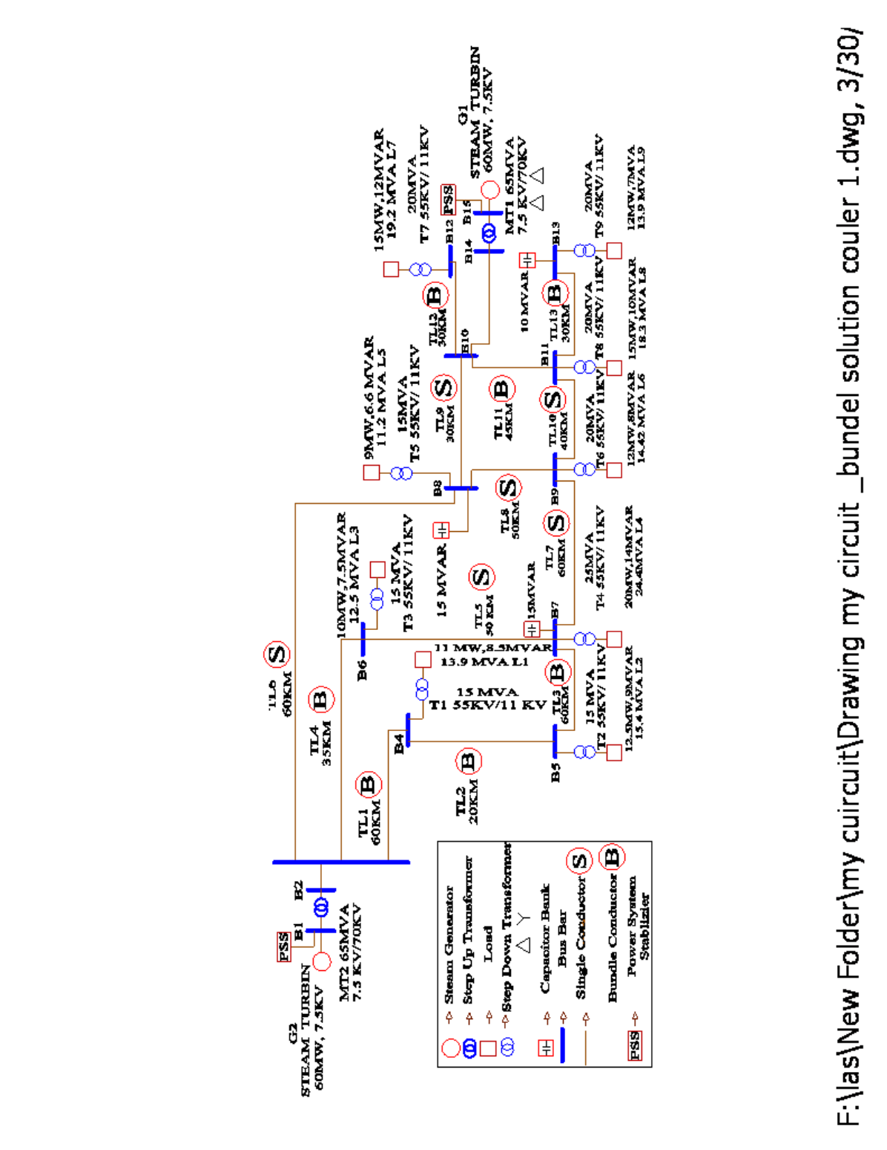
Figure 4.5 Solution 1 (Bundle Transmission Line)
4.4.2 Convert from Single Conductor to Parallel Conductors (Solution 2)
In this circuit, the second solution will be applied which is converting the most heavy loaded transmission line same as bundle conductor into parallel transmission line as shown in figure 4.6. Table 4.9 shows the type of the each transmission line if it is single or parallel conductor.

Table 4.9: Transmission Lines Structure
Transmission line | Type of Transmission line
1 (TL1) | Parallel
2 (TL2) | Parallel
3 (TL3) | Parallel
4 (TL4) | Parallel
5 (TL5) | Single
6 (TL6) | Single
7 (TL7) | Single
8 (TL8) | Single
9 (TL9) | Single
10 (TL10) | Single
11 (TL11) | Parallel
12 (TL12) | Parallel
13 (TL13) | Parallel

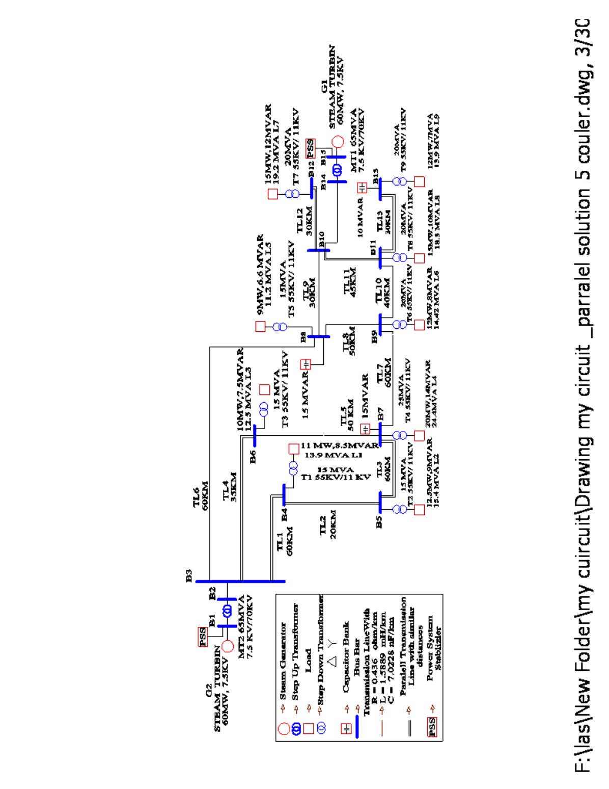
Figure 4.6 Solution 2 (Parallel Transmission Line)
4.4.3 Parallel Generator with Parallel Transmission Line (Solution 3)
In this circuit, the third solution will be applied which is adding parallel steam turbine generators to the main generators (G1, G2) with same specification of transformers connected with timer circuit breakers. At the begging its proposed that there will be only two parallel generators working synchronically, but this solution was not enough to eliminate the overload problem due to the capacity of the transmission line that can not carry the new changes in the generators so some of these transmission lines are changed into parallel transmission line as shown in figure 4.7.
Table 4.10, 4.11 respectively shows the rating of the each steam turbine generators and transformer rating; also table 4.12 deals with the changing of transmission line if it is single or parallel conductor.

Table 4.10: Generator Values
Generator Number | Power Generated | Generator Rating
G1(Main) | 60MVA | 7500
G2(Main) | 60MVA | 7500
G3 (parallel) | 30MVA | 7500
G4 (parallel) | 30MVA | 7500

Table 4.11: Power Transformers Values and Voltage Rating
Transformer Number | Transformer Type | Power Transformer | Transformer Rating
MT1 | Step Up | 65MVA | 7.5kV to 70kV
MT2 | Step Up | 65MVA | 7.5kV to 70kV
MT3 | Step Up | 50MVA | 7.5kV to 70kV
MT4 | Step Up | 50MVA | 7.5kV to 70kV

Table 4.12: Transmission Lines Structure
Transmission line | Type of Transmission line
1 (TL1) | Single
2 (TL2) | Parallel
3 (TL3) | Single
4 (TL4) | Parallel
5 (TL5) | Single
6 (TL6) | Single
7 (TL7) | Single
8 (TL8) | Single
9 (TL9) | Single
10 (TL10) | Single
11 (TL11) | Parallel
12 (TL12) | Parallel
13 (TL13) | Parallel

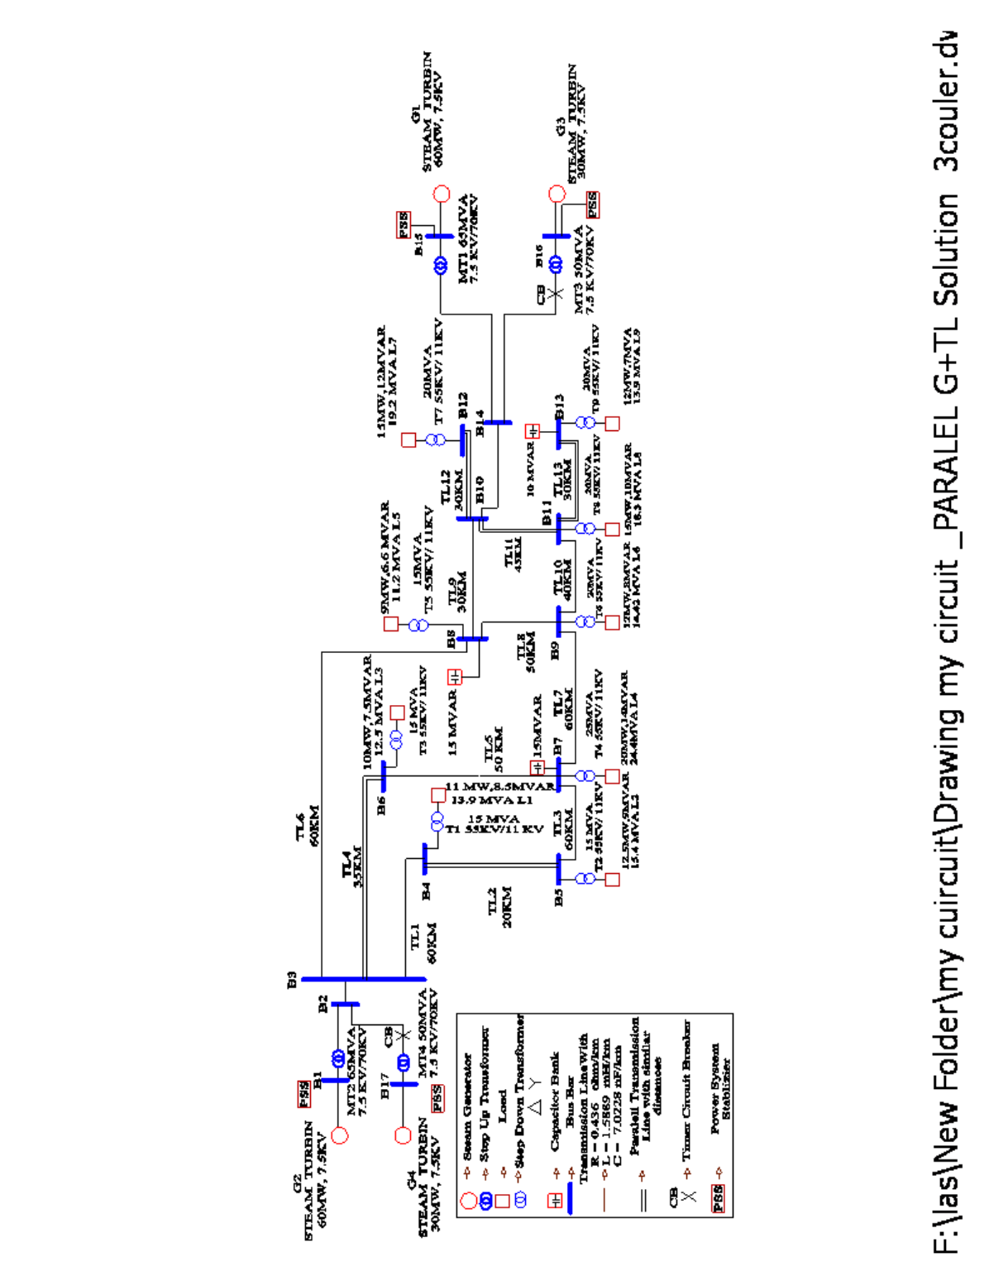
Figure 4.7 Solution 3 (Parallel Generation with Parallel Transmission Line)
4.4.4 Adding Distribution Generator (Solution 4)
In this circuit, the forth solution will be applied which is adding three distribution diesel generators to the overload circuit connected with timer circuit breakers as piecemeal (one by one with different time) ,the places of the distribution generators are chosen beside the most loaded part in the circuit shown in figure 4.8. Table 4.13 shows the rating of two main steam turbine and three diesel generators, table 4.14 represent the transformers specifications especially its type , power, and rating.

Table 4.13: Generator Values
Generator Number | Power Generated | Generator Rating
G1 (Main) | 60MVA | 7500
G2 (Main) | 60MVA | 7500
DG1 (Distribution ) | 20MVA | 4200
DG2 (Distribution ) | 20MVA | 4200
DG3 (Distribution ) | 5MVA | 4200

Table 4.14: Power Transformer Values and Voltage Rating
Transformer Number | Transformer Type | Power Transformer | Transformer Rating
DT1 | Step Up | 20MVA | 4.2KV_70KV
DT2 | Step Up | 20MVA | 4.2KV_70KV
DT3 | Step Up | 20MVA | 4.2KV_70KV

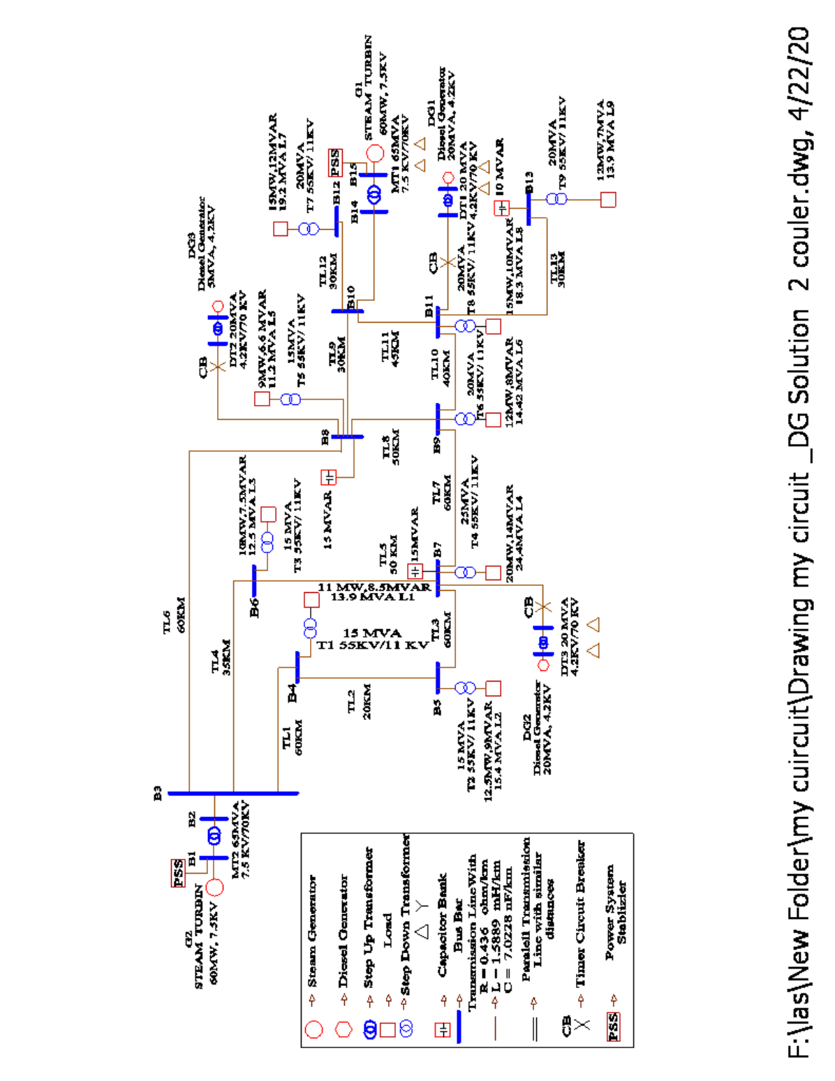
Figure 4.8 Solution 4 (Three Distribution Generation)
4.4.5 Adding parallel Transformer (Solution 5)
In this circuit, the fifth solution will be applied which is adding parallel transformer to the three loaded loads which are (1, 4, 5) as explain above, where these transformers have the same specification working synchronically as shown in figure 4.9.

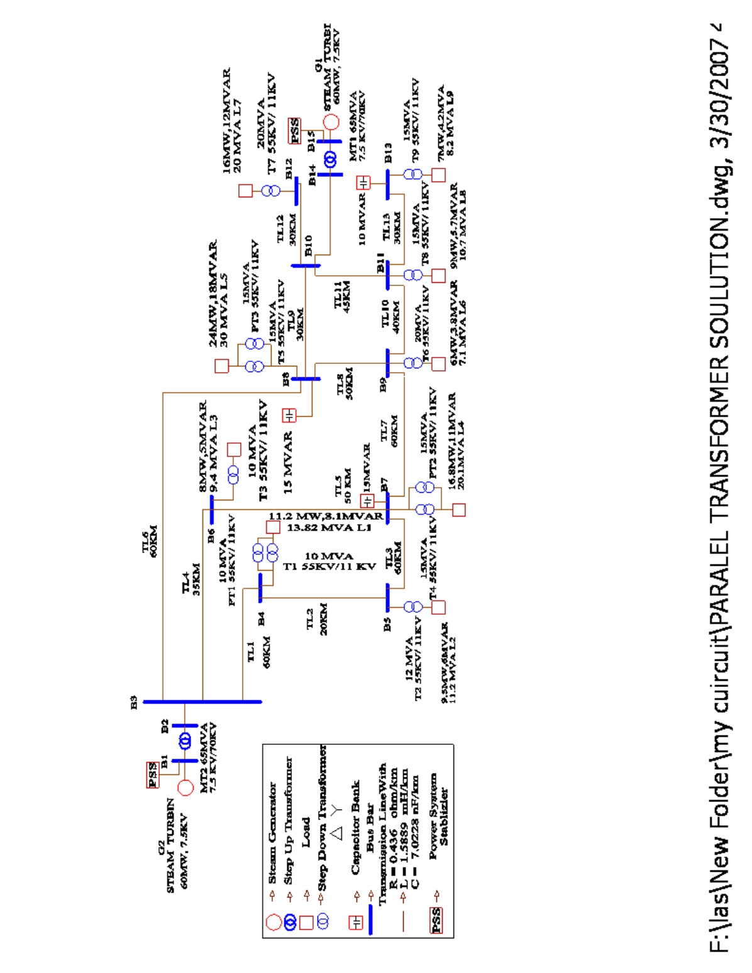
Figure 4.9 Solution 5 Parallel Distribution Transformers
4.5 Results & Analysis
The work was carried out on a Pentium 4, 3.0 GHz CPU with 512 Mb of RAM computer using windows XP. The results are divided into two parts. First part is the transmission line values and the second part is taken as voltage and current in the distribution systems (in the load parts).and the five solutions are summarized in the tables as:
- Solution 1 = Convert from single conductor to bundle conductors
- Solution 2 = Convert from single conductor to parallel conductors
- Solution 3 = Parallel generator with parallel transmission line and
- Solution 4 = Adding distribution generator.
- Solution 5 = Adding Parallel Transformer.

4.5.1 Full Load and Overload Results
Detailed test results obtained both voltage and current values are presented in table 4.16 and 4.17 shown in per unit system, respectively .Comparison of these results clearly establishes the superiority of the proposed solutions to elevate overload problems. Study of Table 4.17 indicates that all the overloads in the distribution side especially loads 1, 4, 6, 8, and 9 suffer from being below the nominal voltage, between 0.8655 to 0.9389KV.
It is seen from the table 4.15 that there are many transmission lines (T.L.) carry currents near the maximum current in the overload circuit which limit the transfer of active and reactive power and drop the voltage at the receiving end to lower the minimum limit. These transmission lines are suggested to be changed to bundle conductors as in solution 1 or parallel T.L. as in solution 2. Also with a an intensive look to tables 4.16 and 4.17 that the voltages of some loads are lowered to less than 0.95 p.u. as a result of lake of transferred power.

Table 4.15: Transmission Lines Current Values (A)
Transmission Line  Number | Full Load  Circuit | Overload Circuit
1 (TL1) | 122 | 142
2 (TL2) | 210 | 265
3 (TL3) | 150 | 167
4 (TL4) | 170 | 210
5 (TL5) | 67.6 | 84.3
6 (TL6) | 62.1 | 74
7 (TL7) | 14.5 | 5
8 (TL8) | 115 | 147
9 (TL9) | 128 | 150
10 (TL10) | 2.76 | 7.74
11 (TL11) | 205 | 267
12 (TL12) | 172 | 206
13 (TL13) | 85.9 | 109

Table 4.16: Voltage and Current Values RMS in Distribution Side
Loads Number | Full load |  | Overload
Loads Number | Voltage Values (KV) | Current Values  (A) | Voltage Values (KV) | Current Values  (A)
1 (L1) | 11.052 | 339.87 | 10.328 | 397.70
2 (L2) | 11.799 | 367.24 | 10.988 | 468.82
3 (L3) | 11.554 | 301.95 | 10.698 | 370.43
4 (L4) | 10.963 | 547.47 | 9.8946 | 669.14
5 (L5) | 11.855 | 335.48 | 11.574 | 357.83
6 (L6) | 10.955 | 346.01 | 10.051 | 401.54
7 (L7) | 11.561 | 480.38 | 10.883 | 579.09
8 (L8) | 10.985 | 371.43 | 9.8864 | 493.71
9 (L9) | 10.796 | 282.14 | 9.5213 | 366.41
Table 4.17: Per Unit Voltage and Current Values in Distribution Side
Loads Number | Full load |  | Overload
Loads Number | Voltage Values | Current Values | Voltage Values | Current Values
1 (L1) | 1.005 | 0.1079 | 0.9389 | 0.1262
2 (L2) | 1.072 | 0.1166 | 0.999 | 0.1488
3 (L3) | 1.050 | 0.0958 | 0.9725 | 0.1176
4 (L4) | 0.996 | 0.1738 | 0.8995 | 0.2124
5 (L5) | 1.077 | 0.1065 | 1.0521 | 0.1136
6 (L6) | 0.995 | 0.1098 | 0.9137 | 0.1275
7 (L7) | 1.051 | 0.1525 | 0.9893 | 0.1838
8 (L8) | 0.998 | 0.1179 | 0.8987 | 0.1567
9 (L9) | 0.981 | 0.0895 | 0.8655 | 0.1163

4.5.2 Transmission Line Changing Results
Voltage instability occurs when the transmission system is not adequately designed to handle reactive power flows. Large amounts of reactive power flows on long transmission lines result in severe drops in voltage at the consumption end, causing the consuming entities to draw increasing currents.
The increased currents cause additional reactive power consumption and voltage losses in the system, leading to lower voltages at the load buses. As the process continues, the voltages collapse further, requiring users to be disconnected to prevent serious damage; therefore the system partially or fully collapses. It is realized that all transmission lines in different cases not overloaded can handle more active and reactive power. For the lines which are loaded its mean those have extra current capacity more than 270A most of these transmission lines are parallel or bundle, which are transmission lines number 1, 2, 3, 4, 11, 12 and 13.
However, bundle and parallel transmission lines depend on the characteristic impedance which varies according to the distance between conductors, distance to ground, and the radius of the individual conductor. As it is known, the resistances R and the$X_{L}$ increase as the length of the line increases, whereas$X_{C}$ decreases with length increasing.
Also as it is closer to the generation station, the maximum transfer of active and reactive power with fewer losses is occurred. For example; in load 1 with distance 60km from generation station the bundle solution increases the voltage efficiency from 0.9389 to 0.998 per unit system .However, in load 4 which is far from the station, the efficiency increased from 0.8995to 0.974 per unit. It is the same for parallel transmission line solution. Table 4.18 introduces the T.L. current values for overload case and for solution 1 (changing to bundle conductors) and solution 2 (switching on parallel transmission lines). From this table it is seen that the changed T.L. can pass more current which means that transfer more active and reactive powers. T. L. 2 and 11 pass currents in the two conductors more than the maximum limit current (270A).

Table 4.18: Transmission Lines Current Values (A)
Transmission Line  Number | Overload Circuit | Solution 1 | Solution 2
1 (TL1) | 142 | 150.65 | 153.01
2 (TL2) | 265 | 285.12 | 308.42
3 (TL3) | 167 | 187.97 | 207.68
4 (TL4) | 210 | 205.65 | 210.58
5 (TL5) | 84.3 | 73.767 | 75.678
6 (TL6) | 74 | 67.423 | 61.024
7 (TL7) | 5 | 12.526 | 18.209
8 (TL8) | 147 | 186.34 | 102.17
9 (TL9) | 150 | 196.25 | 122.63
10 (TL10) | 7.74 | 20.601 | 29.062
11 (TL11) | 267 | 280.95 | 330.57
12 (TL12) | 206 | 214.08 | 217.48
13 (TL13) | 109 | 122.23 | 122.85

Table 4.19 introduces RMS one phase voltages and currents of every load for overload case and solutions 1 and 2. In the overload case loads 1, 4, 6, 8 and 9 are overloaded (its mean the voltages are less than 0.95 p.u.). After changing to bundle conductor all of these load voltages are increased 0.967 p.u. and after switching parallel T.L. they are increased to more than 0.971 p.u. From these results it is seen that changing bundle conductors or adding parallel transmission lines can solve the problem of transmission line limitation and hence can clean the overload and raise the load voltages. The reason for this is because the more transferred power and less voltage drop in T.L.
Figures 4.10 shows phase a voltage image for load 9 in overload case and solution 1, where figures 4.11 shows phase a voltage image for load 8 in overload case and solution 2.

Table 4.19: Voltage and Current Values RMS in Distribution Side
Loads Number | Overload |  | Solution 1 |  | Solution 2
Loads Number | Voltage values (KV) | Current Values  (A) | Voltage values (KV) | Current Values  (A) | Voltage values (KV) | Current Values  (A)
1 (L1) | 10.328 | 397.70 | 10.981 | 422.86 | 11.153 | 429.48
2 (L2) | 10.988 | 468.82 | 11.420 | 487.26 | 11.439 | 488.09
3 (L3) | 10.698 | 370.43 | 11.382 | 394.11 | 11.441 | 396.15
4 (L4) | 9.8946 | 669.14 | 10.718 | 724.83 | 10.707 | 724.08
5 (L5) | 11.574 | 357.83 | 11.724 | 362.47 | 11.739 | 362.92
6 (L6) | 10.051 | 401.54 | 11.045 | 441.25 | 10.677 | 426.54
7 (L7) | 10.883 | 579.09 | 11.304 | 601.49 | 11.483 | 611.02
8 (L8) | 9.8864 | 493.71 | 10.769 | 537.81 | 10.807 | 539.71
9 (L9) | 9.5213 | 366.41 | 10.638 | 409.40 | 10.692 | 411.46

Table 4.20: Per Unit Voltage and Current Values in Distribution Side
Loads Number | Overload |  | Solution 1 |  | Solution 2
Loads Number | Voltage values | Current Values | Voltage values | Current Values | Voltage values | Current Values
1 (L1) | 0.9389 | 0.1262 | 0.998 | 0.1342 | 1.013 | 0.1363
2 (L2) | 0.999 | 0.1488 | 1.038 | 0.1547 | 1.039 | 0.1549
3 (L3) | 0.9725 | 0.1176 | 1.034 | 0.1251 | 1.040 | 0.1257
4 (L4) | 0.8995 | 0.2124 | 0.974 | 0.2301 | 0.973 | 0.2299
5 (L5) | 1.0521 | 0.1136 | 1.065 | 0.1150 | 1.067 | 0.1152
6 (L6) | 0.9137 | 0.1275 | 1.004 | 0.1401 | 0.970 | 0.1354
7 (L7) | 0.9893 | 0.1838 | 1.027 | 0.1909 | 1.043 | 0.1940
8 (L8) | 0.8987 | 0.1567 | 0.979 | 0.1707 | 0.982 | 0.1713
9 (L9) | 0.8655 | 0.1163 | 0.967 | 0.1300 | 0.972 | 0.1306

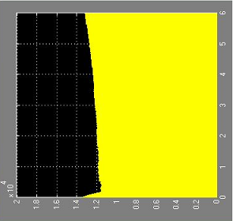
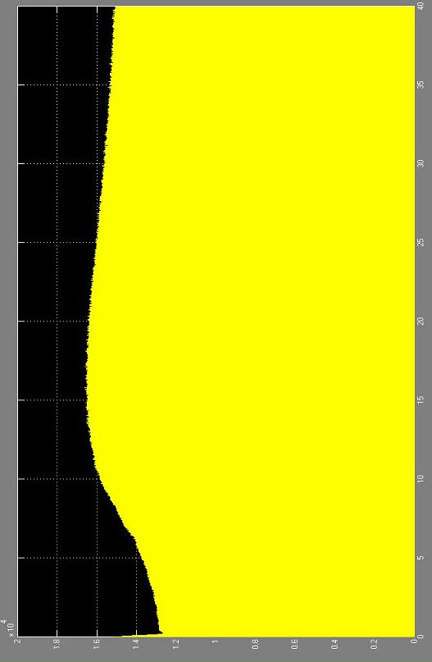

Figure 4.10 Voltage Results in Phase a, of Load 9 (Solution 1)
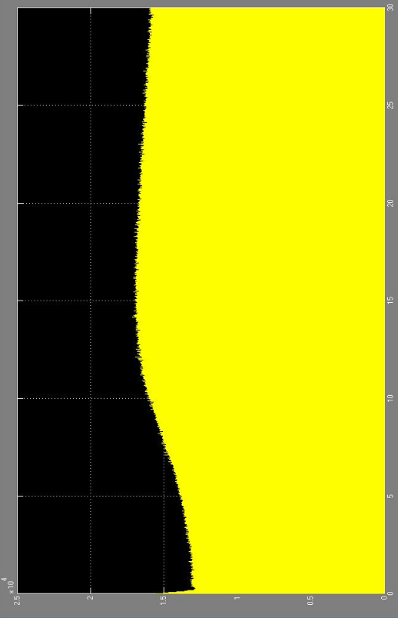

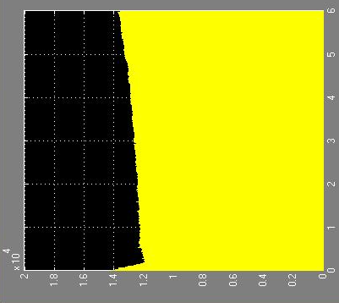

Figure 4.11 Voltage Results in Phase a, of Load 8 (Solution 2)
4.5.3 Generators Changing Results
When the overload is caused from limitation of generated power, then the best way to clean the overload is generating more power by switching on reserve generators or switching on distributed generators. When two or more generators connected in parallel are used to supply a common load, more extra power is provided (more active and reactive power are supplied). Increasing the operating voltage within a voltage class is a technique that has been used for decades. If the system does not reach the upper voltage limit during light loads under normal operation, normal operating voltage can be increased without major configuration changes to the lines.
Table 4.21 introduces the transmission line currents for the overload case and after using solution 3 (switching on reserve generators) and using solution 4 (switching distribution generators). It is seen from column 3 in table 4.21 (solution 3 T.L. currents) that some of them are overloaded or raised to large value which affect the value of increasing generating power. After study it is obvious that these transmission lines should be changed to bundle or adding parallel T.L. In our case adding T.L. in parallel is used in T.L. number 2, 4, 11, 12 and 13. Also it is seen from column 4 in the same table (solution 4 currents) that most T.L. passes less currents especially in the very loaded T.L. because the power is generated and induced near the high overloads. Solution 4 (distribution generators) can solve the problem in a less cost but in worse environmental conditions (because the generators are near the consumers areas).
Table 4.21: Transmission Lines Current Values (A)
Transmission Line  Number | Overload Circuit | Solution 3 | Solution 4
1 (TL1) | 142 | 143.79 | 140.84
2 (TL2) | 265 | 279.60 | 194.83
3 (TL3) | 167 | 176.65 | 117.29
4 (TL4) | 210 | 239.29 | 145.10
5 (TL5) | 84.3 | 103.30 | 26.817
6 (TL6) | 74 | 80.167 | 51.536
7 (TL7) | 5 | 13.959 | 28.775
8 (TL8) | 147 | 107.43 | 95.645
9 (TL9) | 150 | 106.01 | 90.907
10 (TL10) | 7.74 | 26.697 | 27.426
11 (TL11) | 267 | 324.40 | 137.08
12 (TL12) | 206 | 214.55 | 203.81
13 (TL13) | 109 | 121.29 | 121.25

Table 4.22 introduces RMS one phase voltages and currents of every load for overload case and solutions 3 and 4, while table 4.23 introduces the per unit values. In the overload case loads 1, 4, 6, 8 and 9 are overloaded (its mean the voltages are less than 0.95 p.u.). After switching reserve generators in the generating stations all of these load voltages are increased to more than 0.9528 p.u. and after switching on distribution generators near consumers areas they are increased to more than 0.966 p.u. From these results it is seen that switching reserve generators or switching on distribution generators can solve the problem of generating power limitation and hence can clean the overload and raise the load voltages. The reason for this is because the more transferred or generated power and less voltage drop in T.L.
Figures 4.12 shows phase a voltage image for load 2 in overload case and solution 4.

Table 4.22: Voltage and Current Values RMS in Distribution Side
Loads Number | Overload |  | Solution 3 |  | Solution 4
Loads Number | Voltage Values (KV) | Current Values  (A) | Voltage Values (KV) | Current Values  (A) | Voltage Values (KV) | Current Values  (A)
1 (L1) | 10.328 | 397.70 | 10.481 | 403.01 | 10.626 | 395.33
2 (L2) | 10.988 | 468.82 | 11.682 | 498.44 | 11.205 | 478.10
3 (L3) | 10.698 | 370.43 | 11.535 | 399.43 | 11.101 | 384.39
4 (L4) | 9.8946 | 669.14 | 10.539 | 712.69 | 11.005 | 744.25
5 (L5) | 11.574 | 357.83 | 11.672 | 360.86 | 11.835 | 365.88
6 (L6) | 10.051 | 401.54 | 10.558 | 421.80 | 10.843 | 433.20
7 (L7) | 10.883 | 579.09 | 11.328 | 602.80 | 10.761 | 572.63
8 (L8) | 9.8864 | 493.71 | 10.670 | 532.86 | 10.958 | 547.21
9 (L9) | 9.5213 | 366.41 | 10.556 | 406.24 | 10.553 | 406.12

Table 4.23: Per Unit Voltage and Current Values in Distribution Side
Loads Number | Overload |  | Solution 3 |  | Solution 4
Loads Number | Voltage Values | Current Values | Voltage Values | Current Values | Voltage Values | Current Values
1 (L1) | 0.9389 | 0.1262 | 0.9528 | 0.1279 | 0.966 | 0.1255
2 (L2) | 0.999 | 0.1488 | 1.062 | 0.1582 | 1.018 | 0.1518
3 (L3) | 0.9725 | 0.1176 | 1.048 | 0.1268 | 1.009 | 0.122
4 (L4) | 0.8995 | 0.2124 | 0.958 | 0.2263 | 1.000 | 0.2363
5 (L5) | 1.0521 | 0.1136 | 1.061 | 0.1145 | 1.075 | 0.1161
6 (L6) | 0.9137 | 0.1275 | 0.959 | 0.1339 | 0.985 | 0.1375
7 (L7) | 0.9893 | 0.1838 | 1.029 | 0.1914 | 0.978 | 0.1818
8 (L8) | 0.8987 | 0.1567 | 0.97 | 0.1692 | 0.996 | 0.1737
9 (L9) | 0.8655 | 0.1163 | 0.959 | 0.1289 | 0.959 | 0.1289

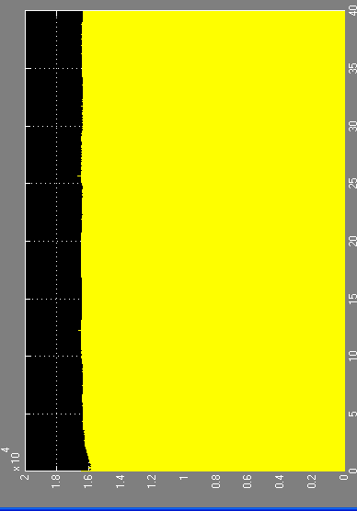

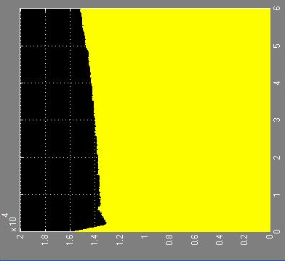

Figure 4.12 Voltage Results in Phase a, of Load 2 (Solution 4)
4.5.4 Transformer Changing Results
It is necessary, however, to increase the voltages of the generators, and to make some adjustments to the settings of the transformer, or possibly some transformer replacements, in order to produce the new operating voltage.
This part is considering the parallel distribution transformer effect. Transformers are important equipment in power distribution system that they can step down high voltages in transmission at substations or step up currents to the needed level of end. As mentioned before the changes were in three loads 1, 4 & 5. Table 4.24 shows that when the increasing of supplying the active and reactive power caused from adding parallel transformers, the transmission lines current values have small increased changes for example transmission line number 6 in overload case is 98.704A and in parallel transformer solution 106.53A.

Table 4.24: Transmission Lines Current Values (A)
Transmission Line  Number | Overload Circuit | Parallel transformer Solution 5
1 (TL1) | 138.44 | 145.97
2 (TL2) | 206.69 | 211.98
3 (TL3) | 152.51 | 1.5519
4 (TL4) | 166.46 | 171.49
5 (TL5) | 68.672 | 74.384
6 (TL6) | 98.704 | 106.53
7 (TL7) | 11.643 | 13.114
8 (TL8) | 60.677 | 57.557
9 (TL9) | 197.10 | 214.89
10 (TL10) | 15.842 | 19.746
11 (TL11) | 187.67 | 191.82
12 (TL12) | 214.45 | 214.16
13 (TL13) | 77.555 | 77.214

Increasing the consumed voltages of the system, make some adjustments to the settings of the transformer, or possibly some transformer replacements, in order to produce the new operating voltage. Tables 4.25 shows the changing in RMS voltage and current values in distribution side especially the 1, 4, 5 loads and table 4.26 shows per unit values. Figure 4.13 represent the graphic results for load 5. From these tables it seen the overloads are raised to more than 0.9632 p.u. thus cleaning overload after using parallel distribution transformers. It is concluded that when the only cause of overload is limitation of distribution transformers, it can be solved by adding parallel distribution transformers to the heavy loaded transformers.

Table 4.25: Voltage and Current Values RMS in Distribution Side
Loads Number | Overload Circuit |  | Parallel transformer Solution 5
Loads Number | Voltage Values (KV) | Current Values  (A) | Voltage Values (KV) | Current Values  (A)
1 (L1) | 10.249 | 392.40 | 10.596 | 405.72
2 (L2) | 11.522 | 358.64 | 11.481 | 357.35
3 (L3) | 11.200 | 292.68 | 11.147 | 291.29
4 (L4) | 10.390 | 577.94 | 10.719 | 596.27
5 (L5) | 10.406 | 864.73 | 10.995 | 913.69
6 (L6) | 10.852 | 213.50 | 10.773 | 211.93
7 (L7) | 10.889 | 603.25 | 10.874 | 602.44
8 (L8) | 10.925 | 322.41 | 10.877 | 321
9 (L9) | 10.838 | 245.08 | 10.791 | 244.01

Table 4.26: Per Unit Voltage and Current Values in Distribution Side
Loads Number | Overload Circuit |  | Parallel Transformer Solution 5
Loads Number | Voltage Values | Current Values | Voltage Values | Current Values
1 (L1) | 0.9317 | 0.1246 | 0.9632 | 0.1288
2 (L2) | 1.0474 | 0.1138 | 1.0437 | 0.1134
3 (L3) | 1.0181 | 0.0929 | 1.0133 | 0.0924
4 (L4) | 0.9445 | 0.1835 | 0.9744 | 0.1893
5 (L5) | 0.946 | 0.2745 | 0.9995 | 0.2901
6 (L6) | 0.9865 | 0.0677 | 0.9793 | 0.0672
7 (L7) | 0.9899 | 0.1915 | 0.9885 | 0.1912
8 (L8) | 0.9931 | 0.1023 | 0.9888 | 0.101
9 (L9) | 0.9852 | 0.0778 | 0.981 | 0.0774

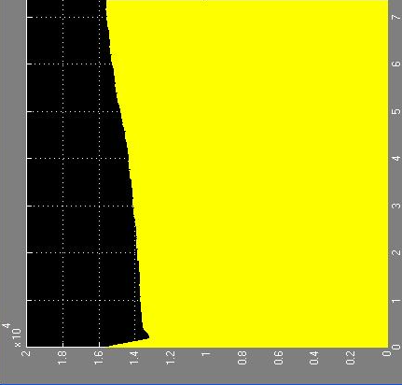

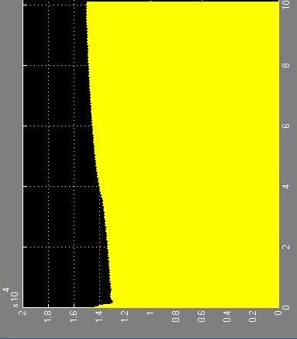

Figure 4.13 Voltage Results in Phase a, of Load 5 (Solution 5)
Table 4.27 shows the CPU time that took for analysis in order to simulate the study cases, the average CPU time depend into computer hardware and program style. For example the overload circuit took 6 sec simulation but the real time was approximately 48 hours.

Table 4.27: CPU Time for the Analysis
- | Over load | Solution 1 | Solution 2 | Solution 3 | Solution 4 | Solution 5
CPU Time (s) | 6 | 40 | 30 | - | 40 | 7.5

4.5.5 Power system Simulator (PSS™E)
Power System Simulator for Engineering tool has become the most comprehensive, technically advanced, and widely used commercial program of its type. It is widely recognized as the most fully featured, time-tested and best performing commercial program available. Unfortunately only full load circuit was simulated in the power system simulator with some changes of power values not exactly same as section 4.3.1 full load circuit. Table 4.28 shows comparison between the result of Matlab program and power system simulator from voltage side, and table 4.29 shows the per unit results.
As its observe some loads in the distribution side are less than 0.95 p.u. in power system simulator results opposite than Matlab program results these different depend on the simulating analysis for each program. Appendix C shows the power system circuit and results

Table 4.28: Comparing Between Voltage Values RMS in Distribution Side (KV)
Loads Number | Matlab  Full load | PSS  Full load
1 (L1) | 10.914 | 10.473
2 (L2) | 11.664 | 10.369
3 (L3) | 11.437 | 11.176
4 (L4) | 10.810 | 10.390
5 (L5) | 11.865 | 10.541
6 (L6) | 10.828 | 10.796
7 (L7) | 11.439 | 10.608
8 (L8) | 10.866 | 11.066
9 (L9) | 10.677 | 10.930

Table 4.29: Comparing Between Per Unit Voltage Values in Distribution Side
Loads Number | Matlab  Full load | PSS  Full load
1 (L1) | 0.992 | 0.952
2 (L2) | 1.06 | 0.942
3 (L3) | 1.039 | 1.016
4 (L4) | 0.982 | 0.945
5 (L5) | 1.077 | 0.958
6 (L6) | 0.987 | 0.981
7 (L7) | 1.039 | 0.964
8 (L8) | 0.987 | 1.006
9 (L9) | 0.97 | 0.993

4.5.6 Some Prices of Power System Components
Utilities are expecting increased competition in the future and are looking for ways to lower their costs. For example the transfer capability of a system may be increased if the thermal, voltage, or system operating constraints of the existing transmission lines can be removed with some of the upgrade remedies, also the option to increase transmission capacity by upgrading the existing lines is of interest because it can be done at considerably less cost than constructing a new transmission line and with a shorter lead time. However, constructing new transmission lines is becoming more difficult with environmental concerns. Table 4.30 shows the approximate prices and cost of some power system components.

Table 4.30: Some Power System Components Prices [47]
Type of Equipment | Approximate Cost
Generator 60MVA (Steam Turbine) | 50 Million-$
Distribution Generator 20MVA(Diesel) | 9000-€
Distribution Generator 10MVA(Diesel) | 5000-€
Distribution Transformer 16-20 MVA | 330000-$
Distribution Transformer 10-12.5 MVA | 294000-$
Transmission line 3layer (66KV-270A) | 25000-$
Transmission line 6 layer (parallel) (66KV-270A) | 40000-$

4.6 Summary
This chapter introduced some solutions to eliminate and alleviate overload power system simulated by Matlab program with different cases. The solutions were tested on proposed overload study case except the parallel transformer solution we separated to see the effect of parallel transformers. From the above results it is proved that the proposed solutions are efficient in keeping the system reliable, stable and not overload.

